MEET THE 2020 MW-ISA AWARD WINNERS!

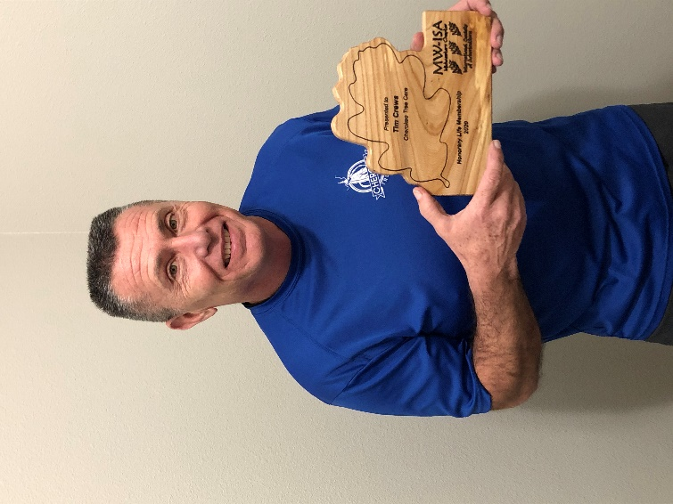

Honorary Life Membership: Tim Crews
Tim is the owner of Cherokee Tree Care and a dedicated professional in all aspects of tree care. He received his MWISA arborist certification in 1995. Selfless dedication, a desire to educate and lift up others and a love for friendly competition has been the benefit of countless arborists around him, young and old. Tim has been active within the Midwest Chapter since 2002 and even served as a Board Member. Tim Crews is a name synonymous with the success of the Midwest ISA Tree Climbing Competition. He continues to serve as the head judge and set-up coordinator for the annual event. For years Tim has donated equipment, networked with colleagues, maintained a keen knowledge of event requirements, and committed countless hours to the benefit of our Chapter’s climbers. Tim’s lead by example approach is a standard that does not go unnoticed by up and coming arborists, he touches all those around him as he leads the event. Tim has truly dedicated his life to the betterment of arboriculture, and most deserving of this award. Congratulations and thank you to Tim for his life dedicated to arboriculture, community, TCC and the Midwest ISA.

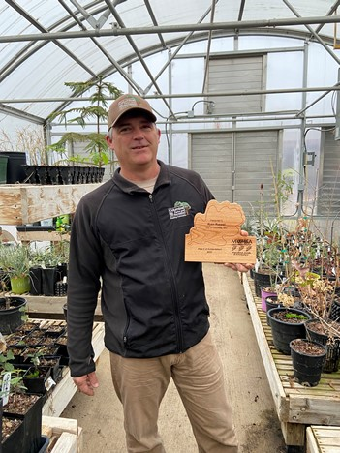
Award of Achievement: Ryan Russell
Ryan Russell continues his dedication to the conservation and propagation of the Maple Leaf Oak (Quercus acerifolia). This little known species is endangered RED status and only found in four known isolated populations in central Arkansas. The newest discovered location, and largest by number, is located on private property. Ryan is now working with the private land owners and potential developers to try to get this small portion of rocky hills dedicated as preserved land or State Park, thus preserving another location of native Oaks.
Navigating the rough terrain and rocky hills to seek out these rare trees is accomplished with pure determination. With the support of retired University of Missouri professor, Dr Mark Coggeshall, and other colleagues, Ryan has acquired funding and located more native Maple Leaf Oak samples for germination at the ex-situ location at Stephens Lake Park Arboretum in Colombia, MO. Ryan’s eﬀorts to preserve the Maple Leaf Oak is aided through a Botanical Gardens Conservation International Grant (BGCI).
Ryan’s eﬀorts have attracted the collaboration with The Morton Arboretum, US National Arboretum and The Dawes Arboretum. As more of his collection grows, Maple Leaf Oaks will be dispersed to these location for further ex-situ conservation of the species.
An unending passion to preserve our oaks and establish ex-situ conservation has Ryan well deserving of this award.
Congratulations and thank you to Ryan for his dedication to arboriculture, conservation and the Midwest ISA.

PRESIDENT’S AWARD: Megan Benes
MWISA Executive Director, Megan Benes was selected for this award by MWISA Chapter President Brett O’Brien as tribute to her efforts in upgrading and improving the services offered to MWISA members. The consistent delivery of a quality quarterly newsletter, an updated and improved website, a switch to convenient and secure electronic voting, are just a few examples of the many advancements Megan has help bring to the chapter.
These examples are relatively apparent to most chapter members, what they may not know is the time and effort it takes to manage the functions of the chapter so that events such as TRAQ classes, tree climbing competition or annual conference flow as smoothly as possible. In his past two years as President, Brett has noted Magen’s ability to unknot difficult, convoluted problems patiently and calmly.
This talent was particularly evident this year with the arrival of Covid-19 and the realization of its negative impact on our chapter’s capacity to hold a traditional on-site conference. As a result of her persistent efforts, Megan, in conjunction with the AAM team, Chapter Board and many others, has been able to develop and host a virtual MWISA Conference on-line. This achievement, a first for our chapter, highlights her administrative skills and illustrates why she so richly deserves this award.

